**Title**: The practical aspects/challenges of IoT Operations.

**Date**: Wednesday 28th December 2022

**Time**: 14:30 PM

**Detail:**Rehani has practical experience in design and construction of microcontroller boards and developing them in IoT and smart renewable energy. He is an expert in data analytics with python and modeler software. Also, he has experience in designing solar power plants and a PV solar test Lab. He is the director of Smart Rasa Group.

He helps mission-driven organizations leverage the power of IoT and data analytics to maximize their impact. He takes pride in listening to customers' needs and crafting well-architected, innovative, and scalable IoT solutions that help his customers achieve their goals.

He is dedicated to engaging with IoT communities, educating, exciting, and inspiring them to build with and contribute to Smart systems.

**The fourth industrial revolution**

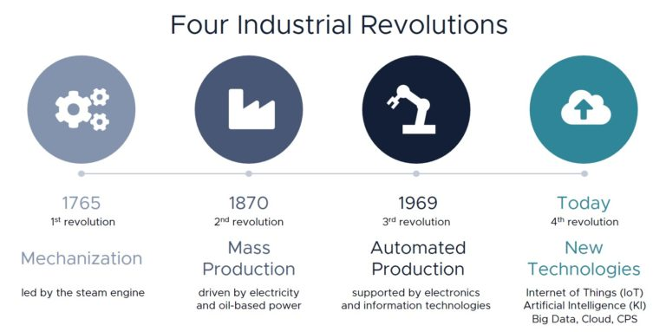

**What is iot?**

The Internet of Things (IoT) refers to the growing network of physical devices, vehicles, and other objects that are connected to the internet and are able to collect and exchange data using embedded sensors, software, and other technologies. These connected devices are able to communicate and interact with each other and with external systems, enabling a wide range of new applications and services.

**Why is iot important and what are the benefits?**

The Internet of Things (IoT) is important because it has the potential to revolutionize many aspects of our lives by enabling new forms of connectivity and automation. Some of the key benefits of IoT are:

1. Increased efficiency: IoT can help to improve the efficiency of various processes by providing real-time data and automated control. For example, a smart irrigation system can use data from weather sensors to optimize watering schedules, reducing water waste and saving resources.
2. Enhanced productivity: IoT can help to increase productivity by automating tasks and providing real-time data and insights. For example, a smart factory can use IoT sensors to monitor production processes and identify bottlenecks, allowing for quicker and more efficient problem-solving.
3. Improved customer experience: IoT can help to enhance the customer experience by providing personalized services and real-time feedback. For example, a smart retail store can use IoT sensors to track customer behavior and provide personalized recommendations, improving the shopping experience.
4. New business opportunities: IoT can create new business opportunities by enabling the development of innovative products and services. For example, a company that provides IoT-based maintenance services can help customers to improve the efficiency and reliability of their equipment.
5. Greater convenience: IoT can make our lives more convenient by enabling automation and remote control of various tasks. For example, a smart home can allow users to control their lighting, heating, and appliances remotely using a smartphone app.

Overall, the benefits of IoT are diverse and varied, and they have the potential to transform many aspects of our lives. However, it is important to carefully consider the security, privacy, and regulatory issues that are raised by IoT.

**Global share of iot projects (iot segments and details)**

It is difficult to accurately quantify the global share of IoT projects in terms of specific sectors or segments, as the IoT industry is rapidly evolving and the adoption of IoT technology varies widely across different regions and industries.

However, some common sectors that have adopted IoT technology include:

1. Manufacturing: IoT can be used to optimize production processes, improve supply chain management, and enhance asset tracking and maintenance.
2. Transportation: IoT can be used to improve the efficiency and safety of transportation systems, such as public transportation, logistics, and vehicle fleet management.
3. Healthcare: IoT can be used to improve patient care and monitoring, as well as to optimize the management of healthcare facilities.
4. Agriculture: IoT can be used to optimize crop management, improve livestock tracking and monitoring, and enhance water and resource conservation.
5. Energy and utilities: IoT can be used to optimize energy generation, transmission, and distribution, as well as to improve the efficiency of water and waste management systems.
6. Retail: IoT can be used to optimize inventory management, improve customer experience, and enhance security and loss prevention.
7. Smart cities: IoT can be used to improve the efficiency and sustainability of urban services, such as traffic management, public transportation, and waste management.

**The top 20 industrial technology trends – as showcased at Hannover Messe 2022**

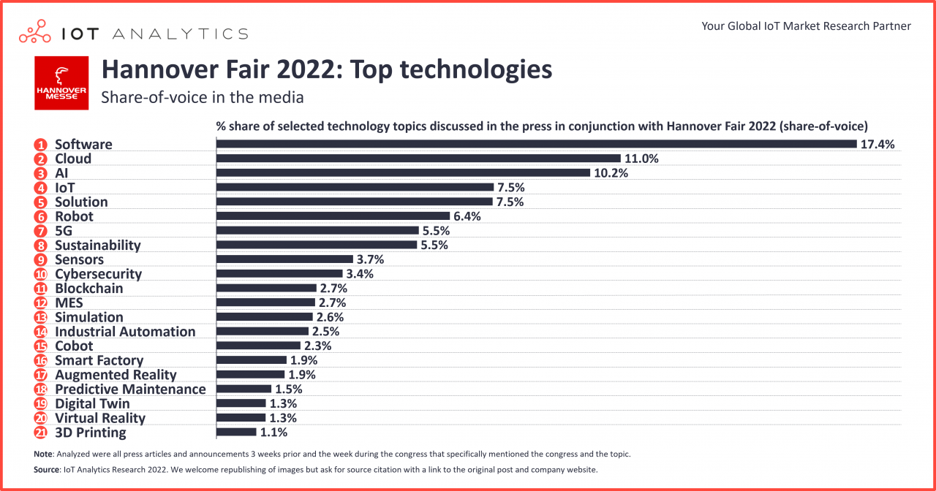

**Total number of the device connections**

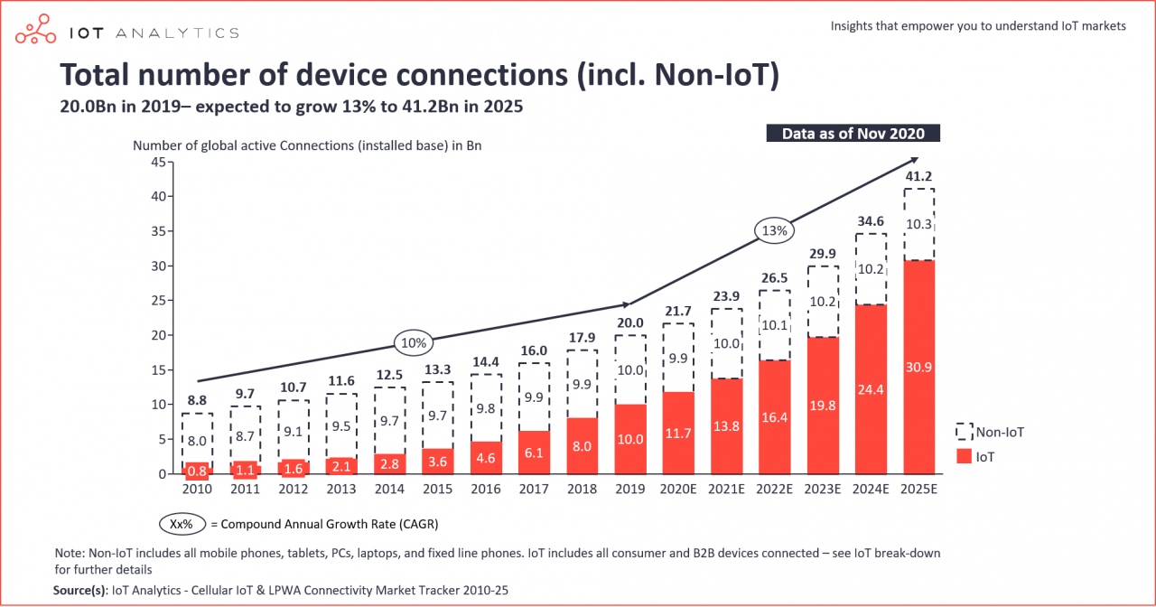

**How does iot work? (Sensors-gateway-cloud/server-mobile app)**

The Internet of Things (IoT) is a system of connected devices, machines, and objects that are able to collect and transfer data over a network without the need for human intervention.

Sensors are the devices that collect data from the environment. They can be used to measure things like temperature, humidity, light, and motion. These sensors are typically small, low-power devices that are designed to be inexpensive and long-lasting.

The data collected by the sensors is then sent to a gateway. The gateway acts as a bridge between the sensors and the rest of the IoT system. It is responsible for collecting the data from the sensors, and then sending it on to the next stage of the system. The gateway is typically a small, low-power device that is designed to be located close to the sensors, in order to minimize the amount of data that needs to be transmitted over the network.

The data then goes to the cloud or a server, where it is stored and processed. The cloud or server can be thought of as the "brain" of the IoT system. It is responsible for analyzing the data that has been collected, and then using that information to control other devices or to provide information to users.

Finally, a mobile app is used by the user to interact with the IoT system. The app allows the user to view and control the devices that are connected to the system. The app can also provide information to the user based on the data that has been collected by the sensors and analyzed by the cloud or server.

Overall, the key elements of an IoT system are: -Sensors that collect data from the environment -Gateway that acts as a bridge between the sensors and the rest of the IoT system -Cloud or Server that stores, processes and analyses the data -Mobile App or other device through which user can interact and control.

**Top 10 IoT applications in 2020 - Which are the hottest areas right now?**

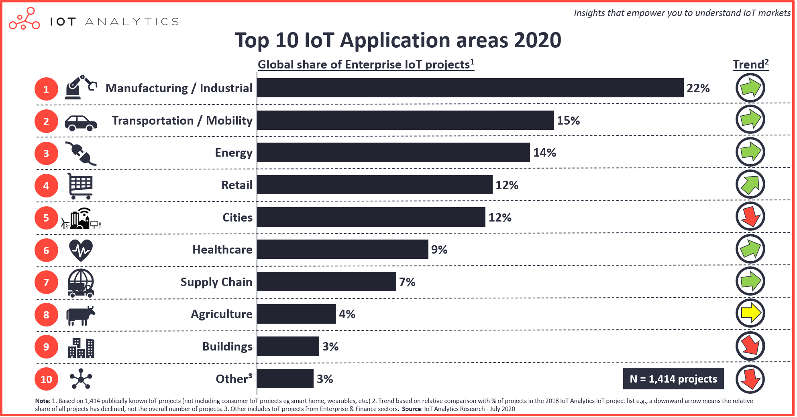

**Architecture layers of iot (device-telecommunication)**

* Device (types of sensors)

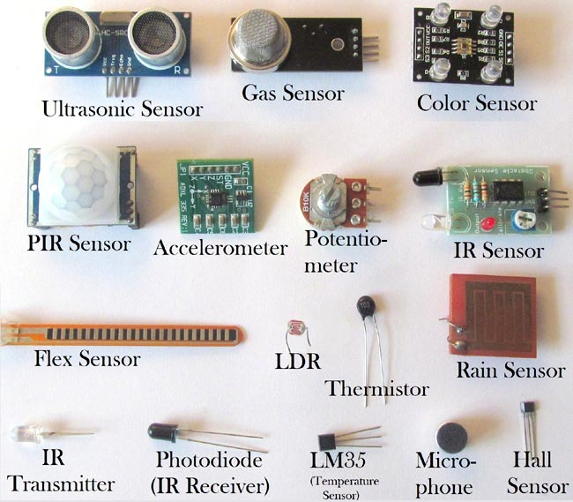

* Types of iot protocols

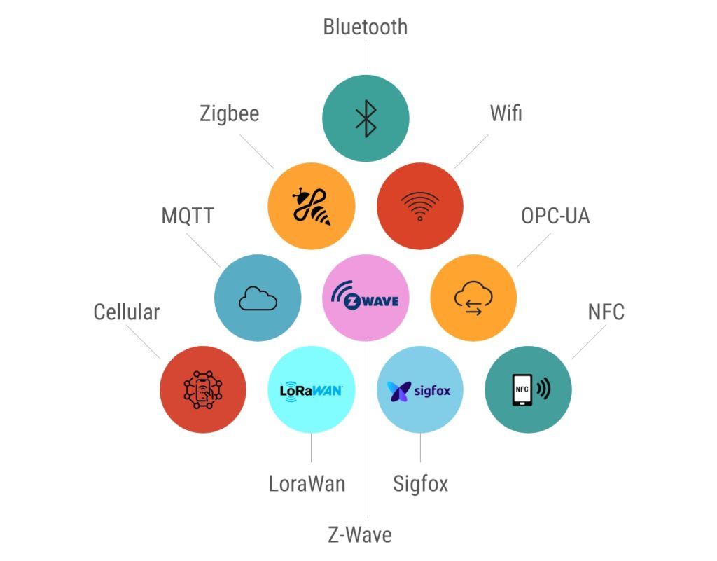

**Comparison of protocols types in iot**

1. MQTT (Message Queuing Telemetry Transport) : It is a lightweight, publish-subscribe based messaging protocol that is particularly well-suited to IoT applications because of its low overhead and small footprint. It's also designed to handle low-bandwidth, high-latency, or unreliable networks. It is widely used in IoT systems to connect devices and brokers.

**Iot platform**

1. Device management
2. Data management
3. Analytics
4. Connectivity
5. Security
6. Application development and management

**And of the seminar**

He introduced the home security devices he brought with him, and he explained how they work in a practical way. (Temperature sensor, camera, motion sensor etc.)

He explained how he connected the devices to the hub and the type of connection between them. He mentioned that he uses the node red platform and that he rents his server from Germany. The reason for this is that he rented a system from Germany and still uses it, he said that the server is cheaper to run a continuous system in his company. He said that he gives 100-200 dollars a year and that around 600 devices are currently connected.